1. Design

We have 2 groups: the normal ‘baseline’ group (N = 20) and the ‘mind-tied’ group (N = 27), which performed a secondary task that involved distinguishing tones.

The videos of the hand reaching for the cup was cut short just before it left the occluder.

At the end of the video, participants were asked to state if the hand was going for the left or the right cup.

2. Measurements

* **Differential Looking Time Scores (DLTS):** this is based on the eyetracking data. Essentially it is calculated as the difference of how long the participant was looking at the target (the cup the hand would reach for based on grip and beliefs) and the distractor (the opposite cup) divided by total looking time, resulting in a score between -1 and 1. A positive number means that gaze was biased towards the target, while a negative number indicates bias towards the distractor.
* **Accuracy of explicit response:** simply, an explicit response towards the target was scores as 1, a response towards the distractor as 0.

3. Data-analysis

I used a fancy linear mixed effects model based on other research and the comments of Rita McNamara during my PAM. It is okay with non-normality and unbalanced groups as opposed to more classic linear models, plus it sees participant as random factor.

I basically tested a full model:

DLTS ~ group + belief + grip + belief x grip

accuracy ~ group + belief + grip + belief x grip

So, looking at the main effects of group, belief and grip, and the interaction effect between belief and grip.

Based on the results I broke the model down to look at the main effects of grip and belief within groups and test our hypotheses that way. I had to cut some corners and ignore some minor technicalities, but the analysis should be to the standard of publication.

4. Results

4.1 DLTS

The test of the full model revealed:

* No significant main effect of group
* A significant effect of belief
* No significant effect of grip
* A significant interaction effect between belief and grip

Below we look closer at these effects.

4.1.1 Baseline group

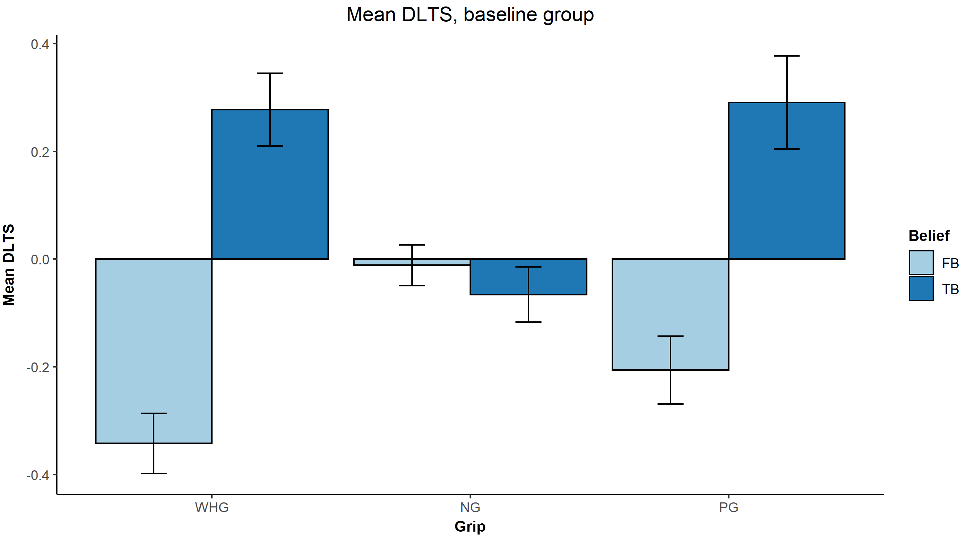

As you can see, participants looked significantly longer at the target in the true belief condition, if the grip was a whole hand grip or precision grip, indicated by a positive DLTS score. Their performance was equal to baseline in the no-grip (fist condition).

In the false belief condition, the participants’ gaze was significantly biased towards the distractor, as indicated by a negative DLTS score, significantly differing from 0. No such difference was found in the no-grip condition. Alas, it seems participants seemed to be largely oblivious to the agent’s belief as far as looking times are concerned.

Note that when tested, the DLTS differences within grip (i.e., the difference between True Belief scores and False Belief scores for each grip condition), differed significantly in the whole hand grip and precision grip conditions, but didn’t differ in the no-grip condition.

4.1.2 Mind-tied group

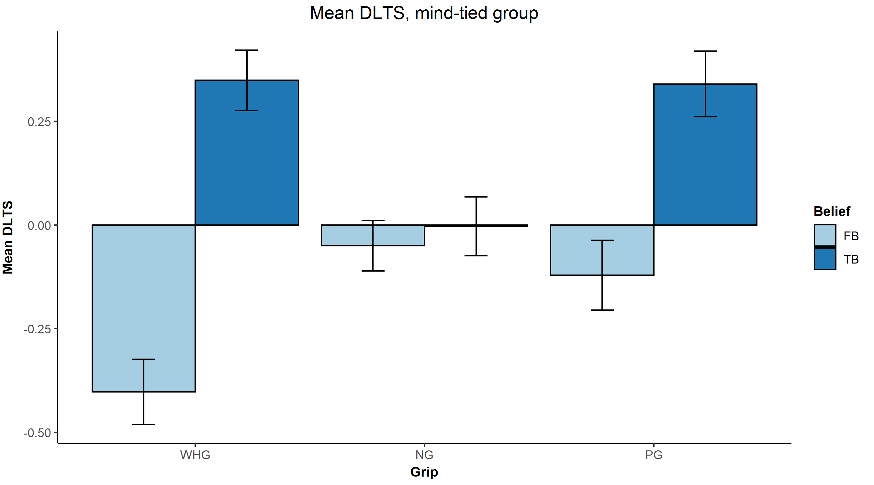

Similarly to the baseline group, participant gaze was significantly biased towards the target location in the true belief condition, but only in the grip conditions with pre-shaping and not the no-grip condition.

In the false belief condition, gaze was significantly biased towards the distractor, but only in the whole hand grip condition. Both in the precision grip and no-grip conditions, gaze bias was equal to the baseline of zero.

Testing the effect within grip conditions (i.e. the difference between true and false belief per grip condition), we found that there was a significant difference in belief scores within both the whole hand grip and precision grip conditions.

4.2 Accuracy of explicit responses

Testing the full model, we found:

* No significant group effect
* A significant effect of belief
* A significant effect of grip
* A significant interaction effect of belief x grip

4.2.1 Baseline group

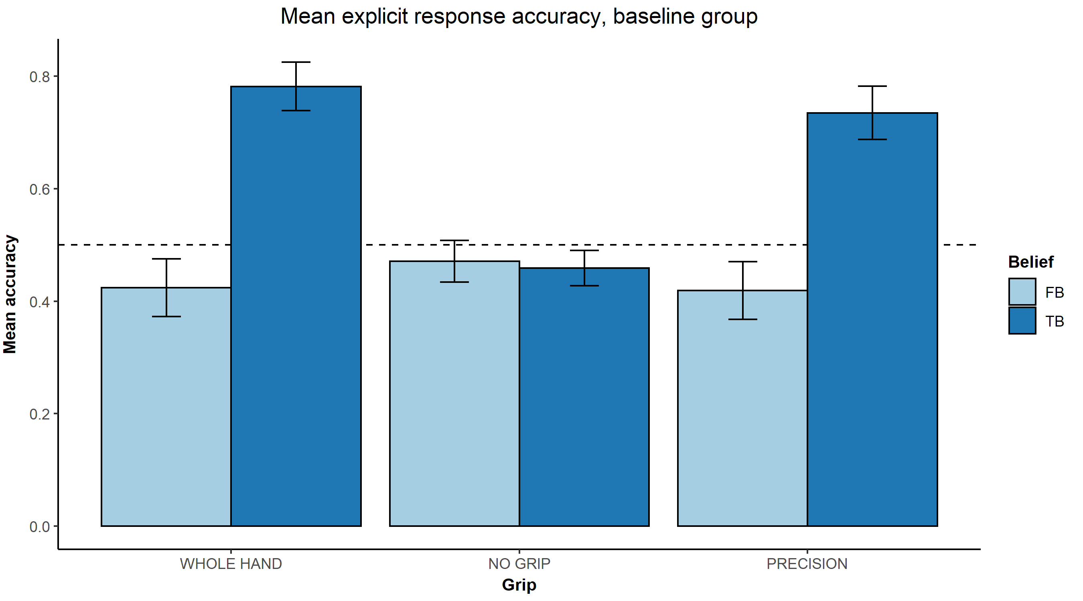

In the true belief condition, we see that the accuracy of participants responses to the question “where will the hand reach for the cup” are significantly higher than chance level (0.5), in both conditions in which there was hand preshaping (whole hand grip and precision grip).

In the false belief condition, the accuracy was **not** different from chance level in any of the grip conditions.

Accuracy was significantly higher in the true belief condition as compared to the false belief condition in both the whole hand grip and precision grip conditions.

4.2.2 Mind-tied group

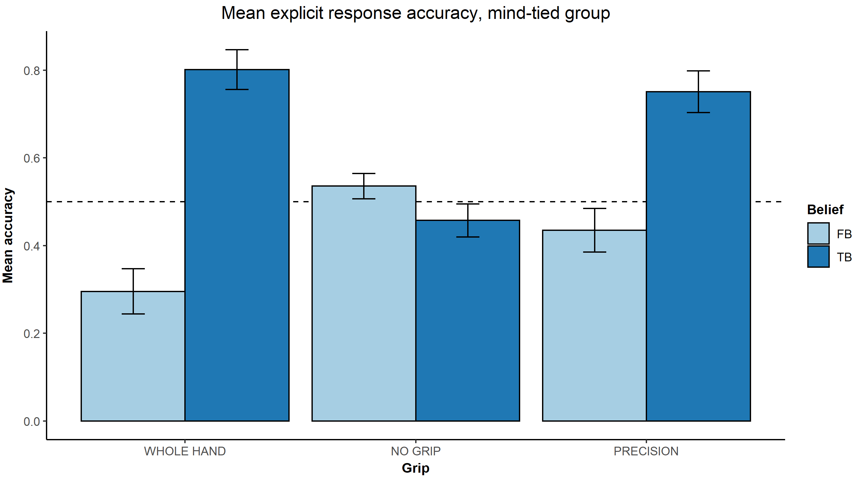

In the true belief condition, accuracy was significantly higher than chance level in the whole hand grip and precision grip conditions, but not in the no-grip condition.

In the false belief condition, accuracy was significantly lower than chance level in the whole hand grip condition, but not in the precision grip or no grip conditions.

Accuracy was significantly higher in the true belief versus the false belief conditions in both the whole hand grip and precision grip conditions.

5. Comparing DLTS and accuracy of explicit responses

There are some issues with running a regular correlation analysis since DLTS is bounded by -1 and 1, and accuracy is a proportion based on categorical data and bounded by 0 and 1. Moreover, both measures are not normally distributed. Therefore, we resorted to using a Spearman’s rank-order correlation analysis.

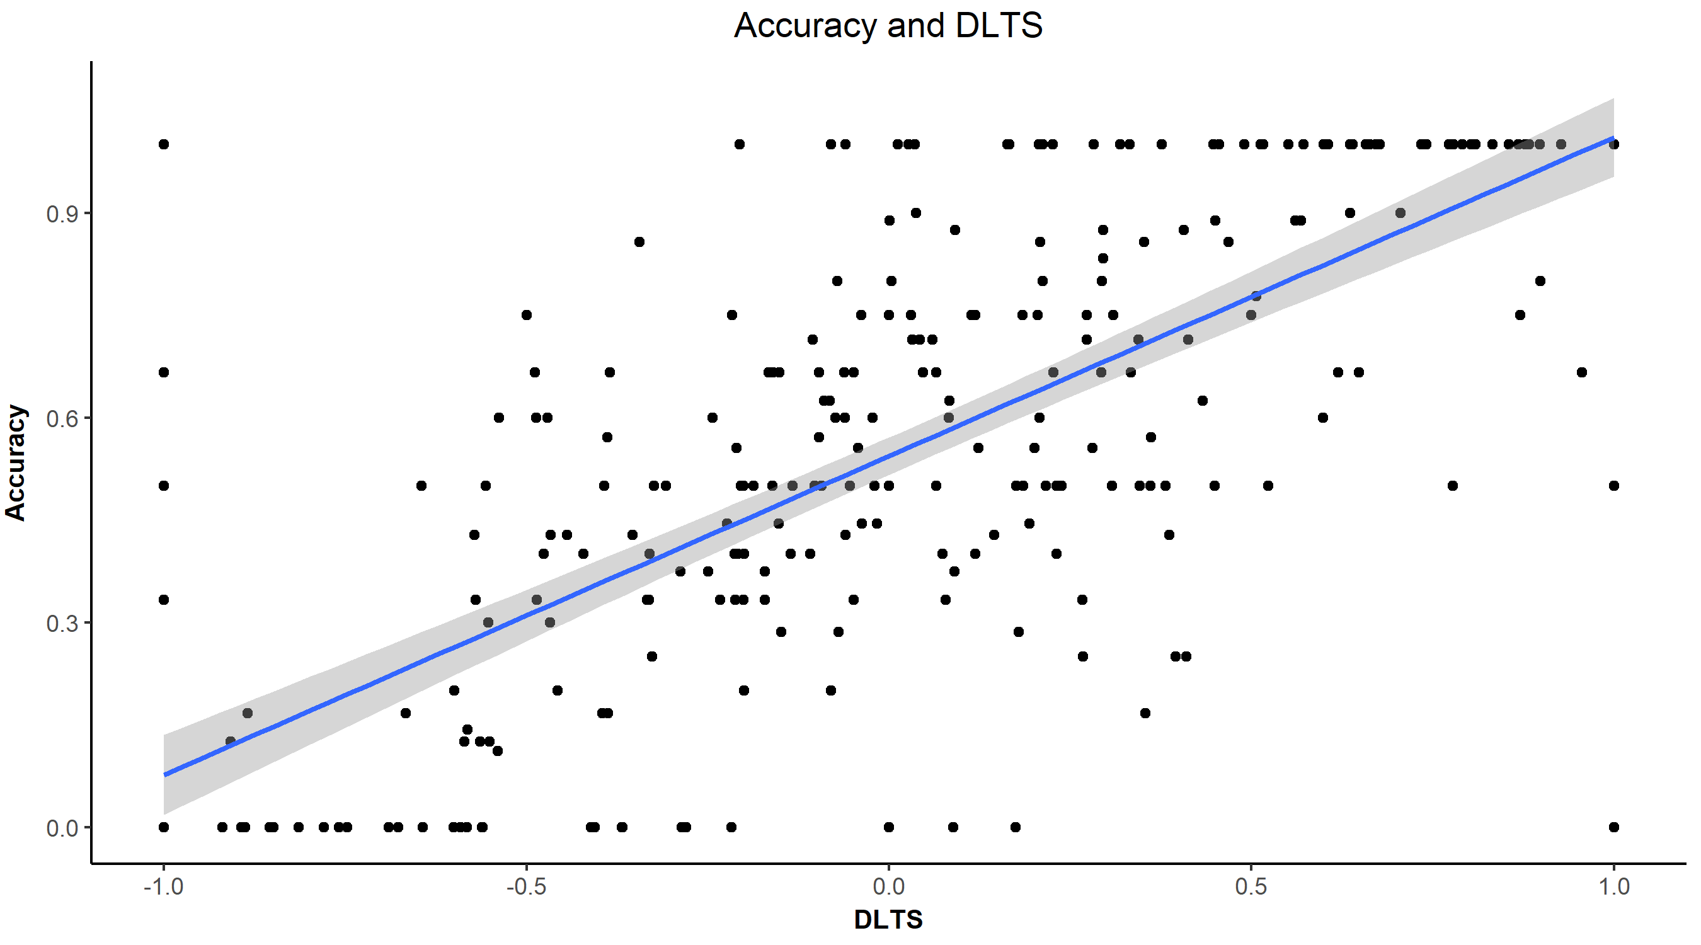

As you can see from the graph above, we can see that there is monotonic and quasi-linear relationship between accuracy and DLTS.

A correlation analysis revealed a significant positive correlation between both measures, with a rho value of 0.726, indicative of a strong positive correlation between accuracy and DLTS.

Possibility: calculate correlation coefficient per belief x grip conditions?

6. Discussion

I still have to wrap my head around this one and do some contemplation. At a glance it seems like accuracy and DLTS, while strongly positively correlated, show some interesting differences.

Looking at the baseline group, we see a significant bias of attention (as measured by DLTS) to the distractor in false belief videos, in line with motor-driven predictive processing. However, looking at their explicit responses, this effect disappears and responses are at practically at chance level. This could potentially be disentangled if we were to look at what method of responding they employed based on the participant debrief, but I’m somewhat reluctant to add in another variable to the model.

Interesting, in the mind-tied group we see an interesting interaction between grip and belief. I.e., both when looking at DLTS and accuracy, we see that the whole hand grip condition behaves as in the baseline group, while in the precision grip condition we see performance at chance level.